Homework #3

  - This grammar represents a language of strings of {a,b}. S, the start symbol will produce at least one A, which in turn produces a string of a’s and b’s, but with more a’s. B, on the other hand, produces more b’s than a’s, and E produces and equal amount.

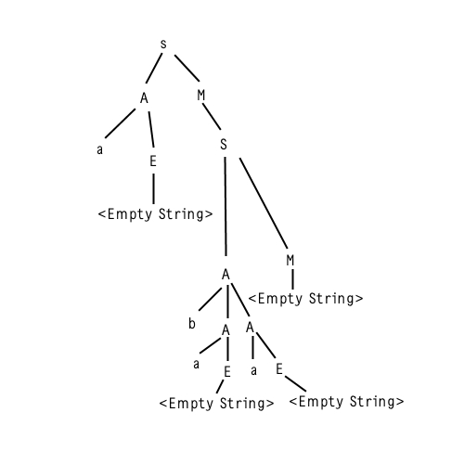
  - The grammar is not LL(1). At expanding E, you can do E -> aB or E -> empty string, as E can be followed after with an a.

  - The grammar is ambiguous because you can create two parse trees for the sequence aaba: 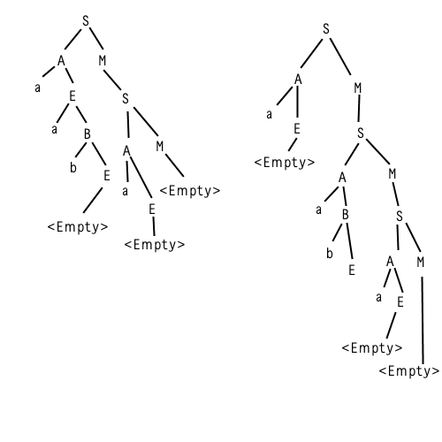

- The grammar is not LL(1) because you can produce two different results for EXP.

- We worked with Maurice for this problem.

Exp-> Number(x (^ Digit )? )? ([+-]Exp)* | x([+-]Exp)*
Number-> -? Digit
Digit-> IntLit
Exp-> Number{Exp.deriv := Number.deriv} ( x {Exp.deriv := X} ( [“^”{Exp.deriv := “^”}] Digit {Exp.deriv := Digit.deriv} )? )? ([ “+” {Exp.deriv := “+"} | “-“ {Exp.deriv := “-“} ] Exp {Exp.deriv := Exp.deriv} ) * | x{Exp.deriv := x} ( [ “+” { Exp.deriv := “+"} | “-“ {Exp.deriv:= “-“} ] Exp {Exp.deriv := Exp.deriv} ) *
Number-> ( “-“{Number.deriv :=“-“} )? Digit{ Number.deriv:= Digit.deriv}
Digit-> intLit{Digit.deriv := intLit.value}

- See github.com/J-Play/MockingBird.

- See github.com/J-Play/MockingBird.

